**1. Calculate the multiplication and sum of two numbers**

**Program:**

a = 5

b = 4

print(a+b)

print(a*b)

#(OR)

ADD = a+b

MUL = a*b

print(ADD)

print(MUL)

**OutPut:**

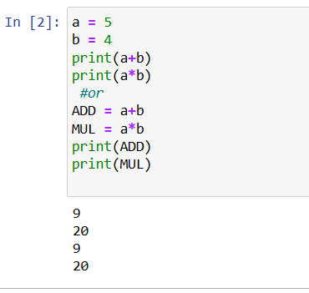

**2. Declare two variables and print that which variable is largest using ternary operators**

**Program:**

a = 15

b = 25

if a > b:

print(f"{a}, is greater than {b}")

else:

print(f"The largest variable is: {b}")

**OutPut:**

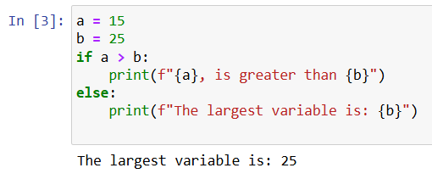

**3. Python program to convert the temperature in degree centigrade to Fahrenheit**

**Program:**

Celsius = 45

Fahrenheit =(Celsius*9/5) + 32

print(Fahrenheit)

**OutPut:**

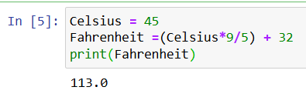

**4. Python program to find the area of a triangle whose sides are given**

**Program:**

base = float(input('Enter the base of triangle: '))

height = float(input('Enter the height of triangle: '))

area = (1/2) * base * height

print(f'Area of triangle with base {base} and height {height} = {area:.2f}')

**Output:**

